



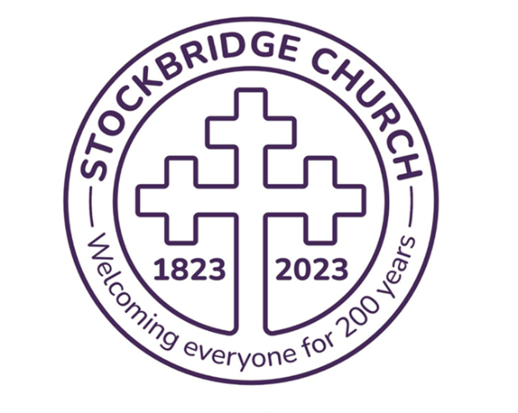

The Bridge

Stockbridge
Parish Church
Newsletter

Saxe Coburg Street, Edinburgh

www.stockbridgechurch.org.uk

Stockbridge
Parish Church
Stockbridge Parish Church of Scotland
Charity No – SC002499
Registered Scottish Charity
Mission Statement
Being aware of the love of God in our lives, we, the congregation of Stockbridge Parish Church, as part of the world church, seek to meet together in worship; to demonstrate faith in God in our everyday lives; to reach out to others, showing God’s love and compassion; and to raise awareness of matters of justice locally and globally.
Summer 2025
Mission Statement

Being aware of the love of God in our lives, we, the congregation of Stockbridge Parish Church, as part of the world church seek to meet together in worship; to demonstrate faith in God in our everyday lives; to reach out to others, showing God’s love and compassion; and to raise awareness of matters of justice locally and globally.

Contact Us
Locum Minister Rev John Munro, 0131 446 9363
revjohnmunro@hotmail.com
Session Clerk (Joint) Ben Bond, 07910 770572 sessionclerk@stockbridgechurch.org.uk
Session Clerk (Joint) Kerr McLaren, 0131 226 2338
Treasurer Kerr McLaren, 0131 226 2338
treasurer@stockbridgechurch.org.uk
Bridge Editor Shona Cameron, 0131 336 3050
bridge@stockbridgechurch.org.uk
Church Administrator Hannah Morris, 0131 332 0122
admin@stockbridgechurch.org.uk
Church Officer Colin Clark, 07510 242018

churchofficer@stockbridgechurch.org.uk

The church office core hours are 10-3 pm, Monday to Friday.

Our worship continues online, as well as in person, on
Sunday at 11am. Watch live, or on demand, by visiting our website, Facebook, or YouTube channel (Stockbridge Parish Church).

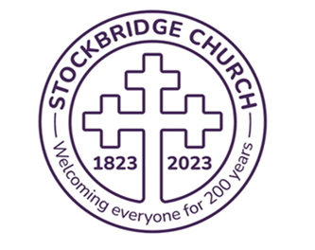
Letter from our Locum
Minister, Rev John Munro

It is something of a ‘truism’ in church circles, but it really is the case that where there is no vision the people perish! All the hard work, the sacrifices of time, talents, and money, the caring for others, the long history of a great church like Stockbridge Parish - none of this will count for very much unless we have a vision for the future.
Of course, we are not alone in all this. This is a time when the Church of Scotland and the Church of England generally are having to renew their vision and plan accordingly for a future that will be very different from our immediate past. Other denominations, perhaps smaller than we are but no less committed, are also facing up to the challenges to the Christian Faith posed by a secular society that is more Christian than it thinks but nevertheless is going its own merry way with its ‘moral compass’ on the one hand and its ‘social media’ on the other, powered by the ubiquitous ‘Smart Phone’ which has been accurately described as ‘a weapon of mass distraction.’ Mind you, there are many good things provided by the secular society and developments in science and technology are working wonders no doubt, but I fear, as someone said to me recently, that as a country we are in danger of losing our ‘soul’.
So it was that one Sunday recently I took the opportunity provided by the passage of scripture set by the Common Lectionary based on the story about the vision the apostle Paul had of a Macedonian begging him to come over and help the people who lived there in what is modern Greece. And help them he did! (Acts 16.6-10)
In these challenging days for the Church do we have a vision for the future? We at least have a Presbytery Plan, one which has undergone several changes since it was launched three years ago. In that time, we must hope that all concerned are persuaded that we belong in Stockbridge and the northern part of the New Town along with churches further ‘up the hill’.
In a recent sermon, I tried to rework a vision for the future of our church and the churches in this area that was first mooted by the late Andrew Wyllie who was the minister of the former St Andrew’s Church in George Street. Andrew shared with me a vision of the churches in the New Town and Stockbridge collaborating in a shared ministry in the belief that we could achieve more as churches working together than we ever could on our own. For as the saying goes, “What churches can do together they ought not to do on their own.” This saying, based on Paul’s idea of the Church as the Body of Christ, encapsulates a sentiment frequently expressed within the Christian Church, emphasizing the importance of unity and cooperation among churches. But before anyone thinks, ‘job done’, we need to persuade ourselves as a congregation and the other churches in the area of Stockbridge and the New Town that this is a vision worth pursuing. It is not about ‘union’ which usually ends badly; it’s about ‘collaboration’ and ‘cooperation.’
I wish all of you a joyful and inspiring summer holiday,
John
___________________________________________________________
Congregational News
We shared the joy of the Asgari family at the baptism of their son Louis on 1st June.

Looking ahead, we have a lot to look forward to in August/September.
See the Fringe programme for the many events being held in our church in August.
In addition, one of our members, Jennie Chalmers, is performing as part of Greenside Productions at the Royal Society of Edinburgh in George St in the persona of Myrtle Throgmorton, in a show entitled “Me and Parky”, incorporating some light-hearted thoughts about Parkinsons.
Buy tickets at Edinburgh Festival Fringe, at https://www.edfringe.com
On the weekend of 27th and 28th September, we plan to open our church for the Doors Open Day weekend. The theme is Architectural Heritage: Windows to the Past, Doors to the Future, so lots of possibilities to invite people in and wow our visitors. Speak to any member of the Kirk Session with your ideas.

___________________________________________________________
Church Fund-Raising:
We are pleased to report that our recent collection for the Storm Damage Appeal fund at the Botanics raised £250.
___________________________________________________________

Presbytery Plan Update
The Kirk Session (a sub-group comprising Be Morris, Ben Bond and Kerr McLaren) are continuing to hold discussions, primarily with Broughton St. Mary’s, about the potential for participation in Mission District Central (M-D C) and have requested Presbytery approval for formal transfer to the M-D C Parish Grouping which includes the New Town Church (formerly St. Andrew’s and St. George’s West and Greenside) and Broughton St. Mary’s.
We are also scheduled to meet with the Presbytery Plan Deployment Group on 1st July to discuss the latest Presbytery thinking on Plan implementation and timelines in general.
For information, we noted that in the Presbytery Deliverances for the Presbytery Meeting of 17th June there is a request to allow Inverleith St. Serf’s to make a call for a Minister of Word and Sacrament though have yet to understand what Mission District North proposals are envisaged for any prospective union between Inverleith St. Serf’s and Granton Parish Church.
We shall provide an update to the Congregation when we have any definitive information to share. In the mean-time we are about to start the process of developing/renewing our own Mission Plan for Stockbridge Parish Church and will be inviting participation and input from the Congregation in due course.
Ben Bond (Joint Session Clerk), Kerr McLaren (Joint Session Clerk)
___________________________________________________________



Feedback from the Stockbridge & Comely Bank Churches Together Meeting.
Ben Bond regularly regularly attends these meetings on our behalf, and gives us here some plans for the future:
“In addition to our church, the grouping currently includes St Stephen's Comely Bank (SSCB), St Ninian's Episcopal Church and St Vincent's Chapel (Episcopal) and Bristo Baptist Church.
John recently highlighted in both his piece "Towards a Sustainable Future" and in his latest letter in The Bridge, that what "churches can do together they ought not to do on their own". Hence, I thought you would all be interested in some of the things planned for the coming months by other local churches in the S&CBCT grouping:
- Local asylum seekers/refugees. Projects include English language learning and social gatherings. More volunteers from our local churches are always welcome and needed (Sat AM, Mon/Wed PM).
- Climate Cafes. Held every couple of months at St Ninian's on Sat AM. The next one is on 14th June, and I have asked for posters to share in our church. Again, folks from Stockbridge are very welcome.
- Litter Picking. There is a plan for local churches, including SSCB and St Ninian's to do a church-led litter pick probably at the end of June or early July, in Inverleith Park or the Water of Leith. Again, our participation would be welcomed. More info/details to follow.
- Study Groups. All churches mentioned that they had some form of Fellowship, Home Groups or Bible Study groups and we discussed the possibility of working and meeting together to undertake some studies together. Number 7 is a possible venue.
- Outdoor Evening Service. This is being planned to take place in St Ninian's church garden later in the summer, to which all S&CBCT churches will be most welcome. More info/details to follow when the date is confirmed.
- Other shared services/events. A number of ideas were floated, in addition to our annual S&CBCT get togethers on Good Friday (to again include a Walk of Witness) and before Christmas for carol singing. A joint musical concert(s) has also been suggested. Apart from the outdoor evening service mentioned above, no firm plans for joint services were agreed.
- Other local churches. There was discussion about reaching out to other local churches and denominations (e.g. Broughton St Mary's, The Bridge Family Church, Take Hold Church, Roman Catholic) to see if they would be interested in engaging (or re-engaging) with S&CBCT.
There is a clear interest among the member churches to do more together where we can, and I feel it is something we should encourage and try to drive forward.
Your views and ideas are very welcome!” Ben Bond
___________________________________________________________
Craft Group
Our next get together will be on Tuesday 24th June from 2pm – 4pm. We meet in No. 7, at 7 Raeburn Place on the last Tuesday of the month.
All crafters are welcome, just bring along your current project.
Judith Walker
___________________________________________________________

Our recent fund-raising activities around May’s Christian Aid week have raised a grand total of £756.25.
Thank you to our talented artist Lana whose works were sold for Christian Aid. Thank you to those who entered the Christian Aid quiz, winner Carolyn Hutchison and the flower quiz, joint winners Lilian Munro and Anne Wallace. The ‘guess who’ competition raised a few smiles and a big thank you to those who delved into their photo albums for a suitable "mug shot". Chris Morrison and Rob Cowie were the joint winners.
Finally, many thanks to those who returned their red envelopes with their contributions, including especially those who were eligible for gift aid, which adds further to the total for Christian Aid.
Fiona McNeilage
___________________________________________________________

Book-keeper position
Stockbridge Parish Church are looking to recruit a part-time book-keeper to support the Treasurer in managing the accounting and financial processes. The role will involve booking and posting transactions on the Xero accounting system which is very user friendly and training will be provided as needed.
We have yet to establish how many hours per week (possibly in the range 10-15 hours but negotiable) will be involved and it is expected that hybrid or home working will be possible.
While we would love to have a volunteer to help, we are prepared to offer a paid post at Real Living Wage rate per hour or better depending upon experience. The role could possibly suit someone retired or a student/young person looking to establish some financial skills.
If you are interested or know of someone who may be interested please contact Kerr McLaren, Treasurer, at 'treasurer@stockbridgechurch.org.uk'.
____________________________________________________
News from the Kirk
Life and Work
Life and Work, the independent magazine of the Church of Scotland, is to cease publication after almost 150 years.
Though firmly rooted in the affairs of the Kirk, it also aimed to cover a broad range of subjects of interest to church-goers across the spectrum, from international affairs and British political and social issues to science, ethics, and the arts.
In the late 1950’s Life and Work was read by almost a quarter of the Scottish population. Last year alone, the magazine made a loss of £133,000. For the first time last year, a majority of people say they are not religious. In the 2002 census, 51% pf respondents said they had “no religion”, up from 37% in 2011.
Proposals will be brought to next year’s General Assembly for a new publication.
___________________________________________________________

Moderator reflects on a challenging yet inspiring General Assembly.
The 2025 General Assembly has come to a close and Church of Scotland members have been urged to go out into the world and make disciples.
Rt Rev Rosie Frew, Moderator of the General Assembly, said God's love surpassed knowledge and is "wide and long and high and deep".
She spoke ahead of an address by Lord High Commissioner Lady Elish Angiolini, the first practicing Roman Catholic to represent His Majesty The King.

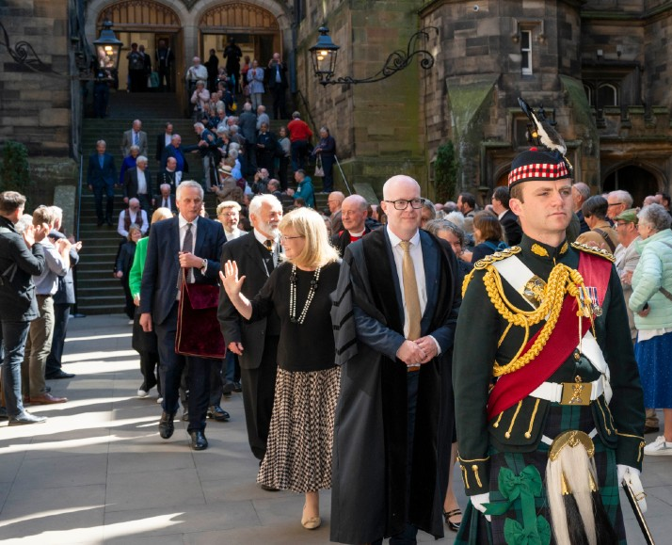
The traditional clapping out ceremony to mark the end of the General Assembly in Edinburgh.
Mrs Frew said: "Remembering Jesus' words, I am with you always - no matter where you are, no matter what you're doing, no matter how you're feeling, I am with you always. Sometimes it can feel really hard. For most of us, our whole Christian life has been lived out against the backdrop of decline - it can feel so dispiriting. This past week has been challenging but it has also been inspiring.
Having Lady Elish as our Lord High Commissioner – such a positive message of unity and friendship, a real living out the St Margaret Declaration (an historic declaration of friendship between the Kirk and the Catholic Church in Scotland).
- the involvement of our youth delegates, young adults involved and invested.
- the singing, the sharing of bread and wine, the conversations enjoyed, the friendships made.
- the contributions of so many people – honest, raw, questioning, encouraging.
I have always taken great encouragement from these words of Eddie Askew from his book A Silence and a Shouting.
He's reflecting on our call to be faithful in planting seeds. And he comments, ‘We may see the harvest, we may not. It is, I believe, a mark of maturity that we learn to accept this, not with indifference or resignation, but joyfully and with imagination, as part of the adventure of Christian living.'
Remember that God is able to do immeasurably more than all we ask or imagine, according to his power that is at work within us."
____________________________________________________
A new pastor has been appointed to work with people walking and cycling the Fife Pilgrim Way.
Rev Simon Hessett will take up his part-time position on 21st July and is looking forward to working with ecumenical partners to encourage greater use of the 64-mile route, and those people seeking to find God in new ways.
The scenic, historic trail is divided into seven sections and winds from Culross or North Queensferry to St Andrews, one of the main pilgrimage destinations in Medieval Europe as people gathered to be near the bones of St Andrew, one of Jesus' disciples. Pilgrims were also drawn to Dunfermline to visit St Margaret's shrine within the Abbey.
The Fife Pilgrim Way pastor is an ecumenical appointment.
Simon, a Church of Scotland minister, brings professional experience in the field of information technology prior to entering ministry training in 2023 and becoming assistant minister at Holy Rude Viewfield Parish Church in Stirling. A keen walker, he organised weekly walks with an ecclesiastical theme while at university, and since then has completed six of Scotland's long-distance routes, including several now recognised as Scottish Pilgrim Ways.
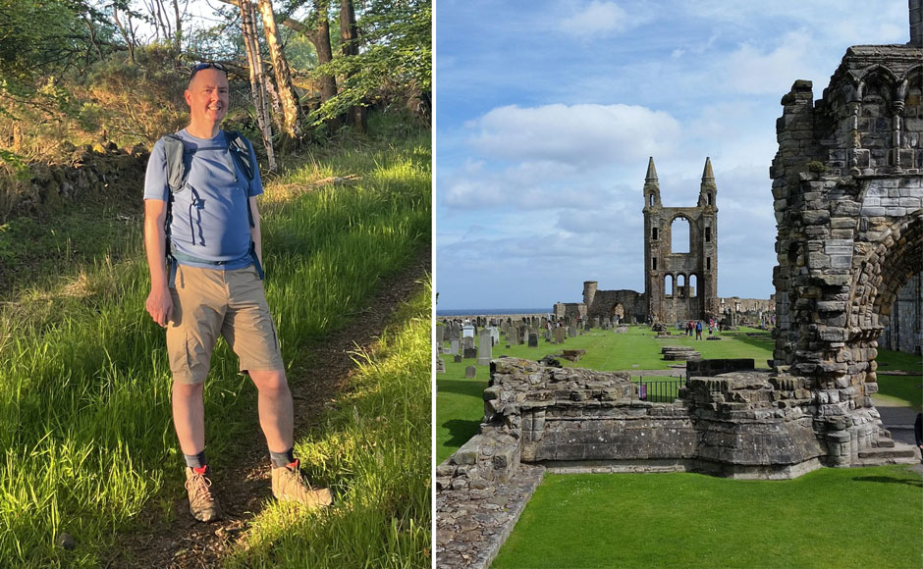

Rev Simon Hessett and St Andrews Cathedral.
Simon said: "This job offers an excellent opportunity to bring together my faith and my love of walking with my organisational, planning and IT capabilities, to further raise the profile of the Fife Pilgrim Way and to develop partnerships to improve the accessibility of the route to all who may wish to walk it."

Spiritual renewal
Rev Alec Shuttleworth, Clerk to Fife Presbytery, said: "The Pilgrim path brings together so many things. "It passes through historic cities and towns with ancient places of worship, as well as modern estates and new towns. It moves from the coal fields of the south and west of Fife to the rich farmlands of the north and east. It follows gentle streams and rugged hillsides, at one moment on remote paths, at another beside a busy motorway. To walk the pilgrim path is to experience that unique diversity of culture, history, economy and attitude that is Fife."
Mr Shuttleworth said the ecumenical appointment symbolises unity out of diversity. "It allows us as churches to walk alongside people as they make their journeys of faith through this beautiful, diverse landscape. We are pilgrims on a journey and companions on the road, we are here to help each other walk the mile and bear the load.”

Rt Rev Rosie Frew offers us her reflection on our troubled times and a prayer for peace.

We turn to God in prayer
Loving God
Father, Son and Holy Spirit,
God in unity, God in community,
we pray for our world.
Where there is war between nations or within nations
we pray for peace.
Where tensions are building
we pray for calm.
Where there is judgement and prejudice
we pray for dignity and respect.
Where there is a break-down in relationship
we pray for openness and understanding.
Where human hearts are breaking
we pray for care and compassion.
Where there is sorrow and loss
we pray for comfort and healing.
We pray for our world,
one world,
God's world,
enfolded in love,
living in unity and community,
this day and all days.
Amen.

Kirk Fellowship Group
The group meets on Zoom on Tuesday evenings from 7pm for about an hour. We have paused our study of the Acts of The Apostles to look at the Letter to the Galatians which is closely linked. We’ll catch up with Acts again after a few weeks.
If you are interested in joining us for informal Bible study with a friendly and supportive group please speak to Ben or Chris.
Judith Walker
_________________________________________________________
Bottle Caps
Thank you to everybody who has collected plastic bottle caps and brought them along to Church over the last few years. Thousands were recycled instead of ending up in landfill.
It is now possible to recycle most caps simply by leaving them on the bottle when you recycle it. There is no longer a need for a specialist recycling service so we will no longer be collecting these at Church.
___________________________________________________________

Your contributions for The Bridge are very welcome
Just email bridge@stockbridgechurch.org.uk, or leave in Bridge pigeonhole, or speak to Shona Cameron in church.
All contributions for the next issue should be e-mailed to Shona at above email address. If you do not have access to email, please phone her.
The deadline for the next Bridge is Sunday 17th August, 2025.


Stockbridge Music Hub
Upcoming events at the Stockbridge Music Hub at the church:
Friday 4th July 1pm - cello and piano concert
Saturday 5th July 6pm - Words and Music
Friday 11th July 6pm - Carlos Quilici, Argentine Tango
Friday 1st August 1pm - violin and piano
Sunday 24th August pm - Wallace Collection Clea Friend
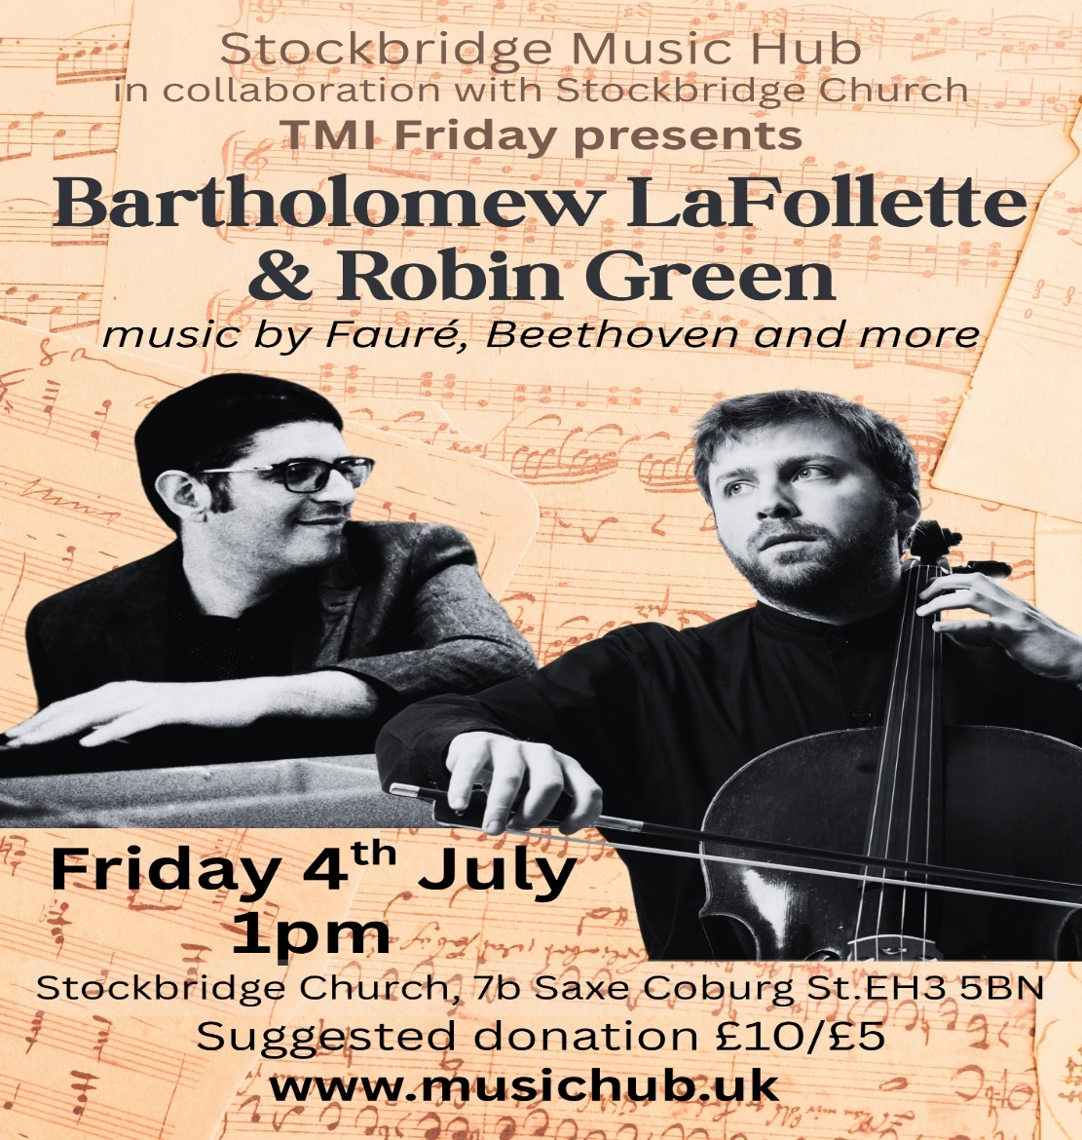
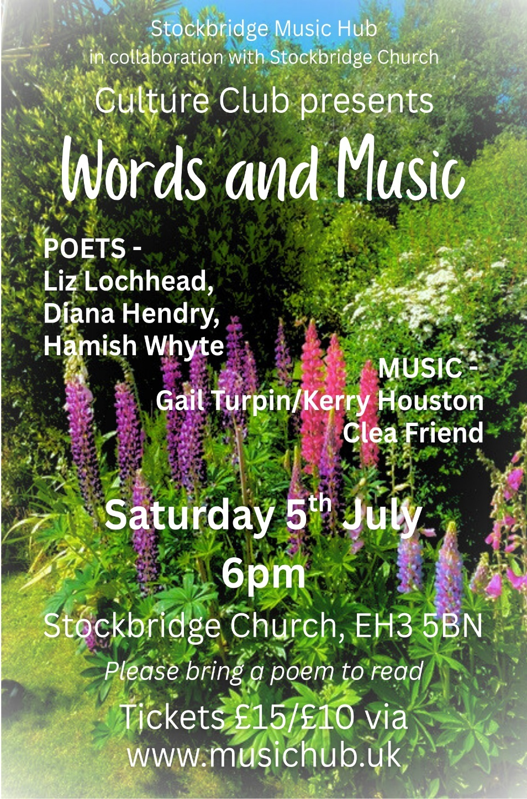




STOCKBRIDGE PARISH CHURCH
7b Saxe Coburg Street Edinburgh EH3 5BN
0131 332 0122

www.stockbridgechurch.org.uk
admin@stockbridgechurch.org.uk

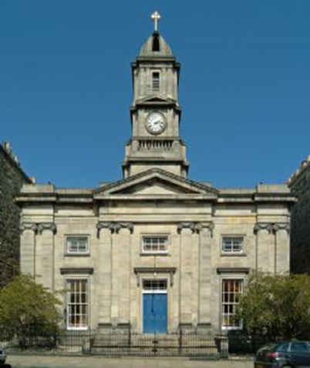

Stockbridge Parish Church of Scotland, Edinburgh
Registered Scottish Charity, Charity No – SC002499

Enquiries about use of the church and halls are welcome, contact the church office, or see our website.

